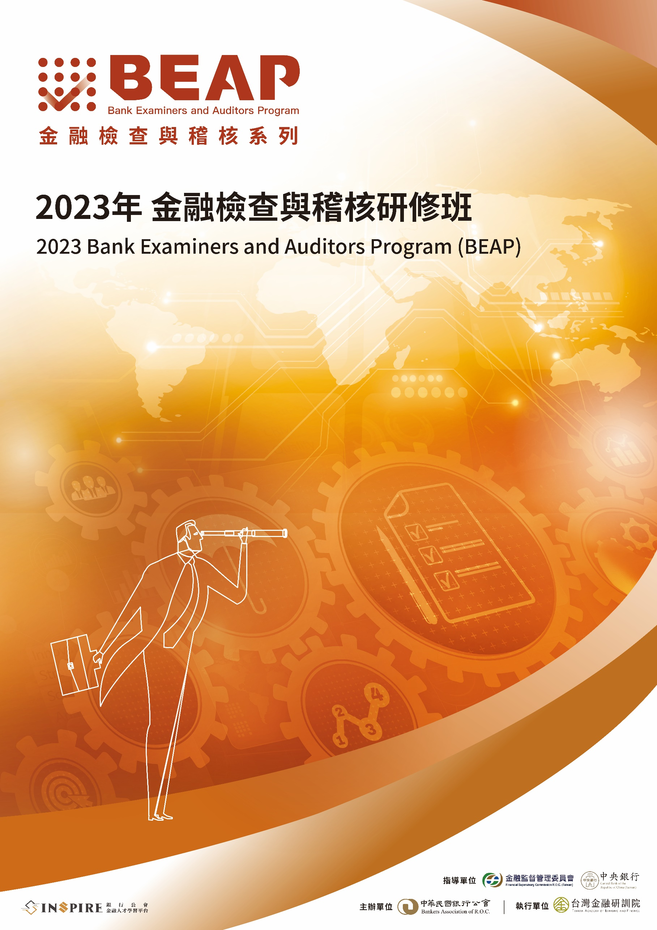

**活動計畫**

本系列研討會可納入稽核人員持續進修時數

「金融檢查與稽核研修班」共約16小時

1. **舉辦目的**

承蒙金管會、央行及銀行公會共同支持，「金融檢查與稽核系列研討會」自1998年推動以來，致力為銀行業監理及內稽專業社群營造跨國交流平台，冀藉由導入國際經驗與最佳實務趨勢，提升國內金融業對於風險之因應能力，為金融的穩健發展奠定良機。

今年度以「國際金融監理趨勢、內部稽核數位轉型、資訊安全、舞弊稽核及永續發展」作為活動主軸，預訂於澳洲雪梨舉行，透過機構考察活動形式，安排參訓人員與雪梨當地金融監理機關及具代表性之跨國銀行集團高階稽核主管進行交流，期藉由雙邊經驗分享與反饋，加速台灣金融監理與內部稽核實務向國際標竿邁進。

1. **參加對象**
2. 金融監督管理委員會、中央銀行、財政部、經濟部及國家發展委員會等主管機關代表
3. 中央存款保險公司人員
4. 中華民國銀行公會金融研究訓練發展基金提撥機構之銀行及金控以下從業人員：

*稽核部門總稽核、副總稽核、稽核室主任、副主任及其他領隊稽核以上之主管

*法令遵循、風險管理、國際金融(OBU)及其他業務相關部門主管、副主管以上之管理人員及從業人員

1. **指導單位**

金融監督管理委員會、中央銀行

1. **主辦單位**

中華民國銀行公會

1. **執行單位**

台灣金融研訓院

1. **活動日期**

2023年11月04日(星期六) ­至2023年11月11日(星期六)

(共八天五夜)

1. **舉辦地點**

澳洲雪梨

1. **活動網頁**

<https://web.tabf.org.tw/page/Inspire/index.html>

1. **參加費用**
2. 金融監督管理委員會、中央銀行及銀行公會金融研究訓練發展基金提撥之機構(限銀行及金控)，學員之培訓費用由銀行公會補助 (含研習課程之教材、講師費、場地費及澳洲雪梨當地交通費等，由銀行公會負擔)，每機構補助一名，共補助25位，歡迎增報候補名額，報名截止後，若補助名額尚有賸餘，候補人員將依各機構報名先後順序遞補，額滿為止。(因名額有限，請儘早報名。)
3. 派訓機構須負擔學員的差旅費及其他訓練費(詳細費用及說明如下表所示)，由本院逕開立發票向派訓機構請款(全額費用一張發票，開立發票品名：教育訓練，無提供旅行社代開收據)。
4. 各項費用及說明：
5. **差旅費**

|  |  |  |  |  |  |  |
| --- | --- | --- | --- | --- | --- | --- |
| 商  務  艙  差  旅  費 | 1 | 機票費(商務艙) | 1 | (人) | $175,000 |  |
| 2 | 住宿費 | 1 | (人) | $65,000 | 單人房*5晚 |
| 3 | 澳洲  簽證費 | 1 | (人) | $500 | 若需旅行社代辦 |
| 4 | 護照新/申辦費 | 1 | (人) | $1,500 | 若需旅行社代辦 |
| 小計 | | 1 | (人) | **$242,000** |  |

|  |  |  |  |  |  |  |
| --- | --- | --- | --- | --- | --- | --- |
| 經  濟  艙  差  旅  費 | 1 | 機票費(經濟艙) | 1 | (人) | $65,000 |  |
| 2 | 住宿費 | 1 | (人) | $65,000 | 單人房*5晚 |
| 3 | 澳洲  簽證費 | 1 | (人) | $500 | 若需旅行社代辦 |
| 4 | 護照新/申辦費 | 1 | (人) | $1,500 | 若需旅行社代辦 |
| 小計 | | 1 | (人) | **$132,000** |  |

1. **其他訓練費**

|  |  |  |  |  |  |  |
| --- | --- | --- | --- | --- | --- | --- |
| 其  他  訓  練  費 | 1 | 餐費 | 1 | (人) | $31,900 | 11/5午晚餐、11/6午晚餐、11/7午晚餐、11/8午餐晚宴、11/9午晚餐、11/10午晚餐 |
| 2 | 保險費 | 1 | (人) | $1,700 | 旅遊平安險1000萬元，意外醫療險100萬元。 |
| 3 | 旅行社  服務費 | 1 | (人) | $20,000 | 旅行社行政服務費、領隊及司機小費等。 |
|  |  | 小計 | 1 | (人) | **$53,600** |  |

註1本活動無法使用愛學習點數支付。

註2參訓學員若自行安排機票、住宿，相關交通安排敬請自理。

1. **報名方式**
2. 請自即日起至112年9月15日(星期五) 17:00(報名截止日)為止，由機構薦派報名，請填具招生函文附件「2023年金融檢查與稽核研修班參訓人員報名表」，以E-mail 方式回傳至本院報名組(regosd@tabf.org.tw)，並收到本院回覆始可完成報名手續。
3. 參訓名單異動或取消費用說明：
   1. 已報名而不克參加欲取消或欲申請更換參訓學員名單，請於112年9月15日(星期五)17:00(報名截止日)前以E-mail書面通知本院客戶服務中心報名組，派訓機構不須負擔取消或異動換人的衍生費用。
   2. 於報名截止日後取消或異動參訓學員名單，將由派訓機構自行負擔以下因差旅安排所衍生之相關費用：
      * 1. 差旅費項目相關取消費(包括機票及住宿，將依照航空公司退票規定及飯店房間取消條款，向派訓機構收取費用。實際確切金額另行通知)。
        2. 其他訓練費(餐費、保險費、旅行社服務費) 新台幣$53,600元整。
4. 為利後續行政作業程序，報名作業建請由派訓機構人資窗口統一報名，請務必配合以email 方式提供報名所需各項文件，若文件有缺漏或報名方式不合規定，則視同報名未成功。
5. 如超過報名截止日報名，經濟艙與商務艙機票費用將依實際報名時間點所訂之艙等費用為準。
6. 因疫後機票及飯店供應不穩定，可能因機位或房型不足，無法滿足差旅安排之需求，本院保留統籌分配之權利，敬請提早報名。
7. 活動出發前一週，將寄發行前通知信與團員手冊電子檔，提供團員參考詳細行程及注意事項。紙本團員手冊將於活動出發當日發放。
8. 本活動如有洽詢事宜、計畫內容請賜電本院海外業務發展中心劉專案副理(電話：02-33653549)；報名手續請賜電本院客戶服務中心報名組(電話：02-33653666轉分機 610、614)。
9. 平和旅行社聯繫方式
   1. 陳淑靜女士：christina0824@gmail.com；02-2706-8638 or 0935-778-213
   2. 王意惠女士：pinho111@pinho-travel.com；02-2706-8638
10. **活動內容**

**\*本院保留變更本活動內容及講座、講題、時間安排等權利；活動資訊如有異動，以本院更新公告為準。**

| **時間** | **主題(暫定)** | **演講者**  **(皆為敬邀中)** |
| --- | --- | --- |
| **Day 1-2**  **11/04-05** | **去程建議航班: 華航CI51**  **11/04 23:55(TPE)桃園出發**  **11/05 12:15(SYD)抵達雪梨** | |
| **飯店下榻休息** | |
| **Day 3**  **11/06**  **10:00-12:00** | **Strengthening Bank Governance and Risk Management: Insights from Australian Financial Regulators**   * Recent Regulatory Evolutions and Key Risk Issues: Overview of recent regulatory developments in Australia, Identification and assessment of key risk issues in the banking sector, Regulatory perspectives on cybersecurity risks and evolving threats * Regulatory Responses and Expectations: Regulatory measures and initiatives to mitigate risks, Expectations for senior management in banks regarding risk oversight, Expectations for auditors in assessing and monitoring risk management practices * Findings from Bank Examinations: Key findings and insights from recent bank examinations, Analysis of emerging trends and areas for improvement identified in examinations * Q&A (30 minute) | **APRA** |
| **Day 3**  **11/06**  **14:30-16:30** | **Evolving Value Proposition & Role of Internal Audit in the Transforming Banking Industry**   * Overview of Global Risk Evolutions in Banking & Auditors' Role in Navigating New Market Environments * Evolving expectations for auditors in banks & How to Enhance risk response and resilience through effective internal audit practices * Transformation of Internal Audit Functions: Establishing a forward-looking risk-based audit methodologies, Leveraging emerging technologies for proactive risk identification * Real-world examples showcasing the strategic value of internal audit and Demonstrating the impact of transformed internal audit on organizational success * Facilitating the Transformation of Internal Audit: Change management strategies for successful internal audit transformation, Building partnerships and collaboration with key stakeholders, Continuous learning and professional development for auditors * Q&A Session (30 minutes) | **Deloitte Australia** |
| **Day 4**  **11/07**  **10:00-12:00** | **Driving Digital Transformation in Internal Audit**   * Digital trends shaping the banking industry & Implications for internal audit functions in banks * Leveraging Technology for Enhanced Audit Effectiveness: Digitization of audit processes for efficiency gains, Leveraging data analytics for predictive risk identification and audit insights * Transformation of Internal Audit Processes: Redesigning audit methodologies for the digital environment, Implementing agile audit practices for faster response to emerging risks * Developing Digital Skills and Capabilities: Fostering a culture of innovation and continuous learning, Collaboration with technology and data experts within the organization, Building strong relationships with technology and business units, Collaboration between internal audit and other assurance functions * Case Studies: What could we learn from Success and Failures * Q&A Session (30 minutes) | **FIS** |
| **Day 4**  **11/07**  **14:30-16:30** | **Driving Sustainable Banking: Insights for Bank Internal Auditors**   * Paving the Way for Net-Zero Emissions: Catalysts and Incentives for Banks * Sustainability in Australian Banking: Embarking on a Journey Towards Change * Upholding Sustainable Governance: Evaluating Framework Effectiveness * Integrating Sustainability into Risk Management: Seizing Opportunities, Mitigating Risks * Auditing the Future of Sustainable Finance: Products and Services * Q&A Session (30 minutes) | **S&P** |
| **Day 5**  **11/08**  **10:00-12:00** | **Driving Sustainable Banking: Insights for Bank Internal Auditors**   * Key drivers and motivations for banks to move toward net-zero emissions & Role of internal auditors in promoting sustainability within banks * ANZ's Approach to Sustainable Banking: ANZ's sustainability journey and commitments, Strategies and initiatives to achieve sustainability goals, Alignment of internal audit with ANZ's sustainability agenda * Driving Sustainability Governance: Assessing the effectiveness of sustainability governance frameworks, Collaborating with management to enhance sustainability governance practices, Providing assurance on sustainability governance to stakeholders * Integrating Sustainability into Risk Management: Identifying and assessing sustainability risks and opportunities, Incorporating sustainability factors into risk frameworks, Evaluating the effectiveness of sustainability risk management controls * Auditing sustainability-related financial products and services: Assessing adherence to sustainability criteria and reporting standards, Evaluating the effectiveness of sustainability-related risk management * Q&A Session (30 minutes) | **ANZ** |
| **Day 5**  **11/08**  **14:30-16:30** | **Driving Digital Transformation in Internal Audit**   * Digital trends shaping the banking industry & Implications for internal audit functions in banks * Leveraging Technology for Enhanced Audit Effectiveness: Digitization of audit processes for efficiency gains, Leveraging data analytics for predictive risk identification and audit insights * Transformation of Internal Audit Processes: Redesigning audit methodologies for the digital environment, Implementing agile audit practices for faster response to emerging risks * Developing Digital Skills and Capabilities: Fostering a culture of innovation and continuous learning, Collaboration with technology and data experts within the organization, Building strong relationships with technology and business units, Collaboration between internal audit and other assurance functions * Case Studies: What could we learn from Success and Failures * Q&A Session (30 minutes) | **CBA** |
| **Day 5**  **11/08**  **Night** | **金融同業交流晚宴**  **Dinner Reception** | |
| **Day 6**  **11/09**  **10:00-12:00** | **Strengthening Fraud Risk Management in Digital Age: Insights for Bank Internal Auditors**   * Key fraud trends and emerging risks in the banking sector: How are emerging technologies changing the global frauds landscape, Implications for internal auditors in managing fraud risks, Role of chief auditors in safeguarding banks against fraud incidents * PwC's approach to fraud risk management and Alignment of internal audit with the bank's fraud risk management initiatives, Assessing and monitoring fraud prevention controls, Collaboration with stakeholders in strengthening anti-fraud measures * Improving the effectiveness of fraud risk management by technologies: Fraud risk identification, Assessing fraud prevention controls * Fraud Incident Response and Investigation * Case Studies on lessons learnt from fraud audits and investigations * Q&A (30 minutes) | **PwC Australia** |
| **Day 6**  **11/09**  **14:30-16:30** | **Insights into Bank Auditors' Strategy to Fortify Cybersecurity Management in Open Banking Environments**   * Changing Banking Landscape & Implications for Bank Auditors: Key technologies shaping open banking environments (i.e cloud, APIs, machine learning, etc), and new emerging cyber risk challenges facing banking industries nowadays * Responding to Rising Cybersecurity Threats: Strategies for enhancing cybersecurity resilience in open banking, Risk-based approaches to cybersecurity controls and incident response * Strengthening the Value of Internal Audit in Cybersecurity Risk Management: Evaluating the effectiveness of cybersecurity governance frameworks, Aligning internal audit with evolving regulatory requirements, Assessing and monitoring cybersecurity controls, Collaboration with stakeholders to strengthen cybersecurity practices * Q&A (30 minutes) | **KPMG**  **Australia** |
| **Day 7-8**  **11/10-11** | **11/10(五) 10:00-12:00**  **學員分組心得分享活動** | |
| **返程建議航班: 華航CI52**  **11/10 22:10(SYD)雪梨出發**  **11/11 04:20(TPE)抵達桃園** | |